alley Ad Tiles
  - Fund the GL Spirit of Community Scholarship
$150 1st year, $100/year each year afterward

Ad Tiles – 2’X4’ color, 19 tiles available
The alley is a great way to get your business name exposed to the Carthage and other local communities: churches, businesses, organizations, families, and league bowlers. Your ad lets community members know you value education and the future of our young people.
The advertising tiles are set just above the lanes in the most visible area of the alley. Tiles are conveniently scaled for a business card design.
Our goal is to offer 3 scholarships a year to local high school graduates planning to attend college or technical school to earn a degree or certificate.
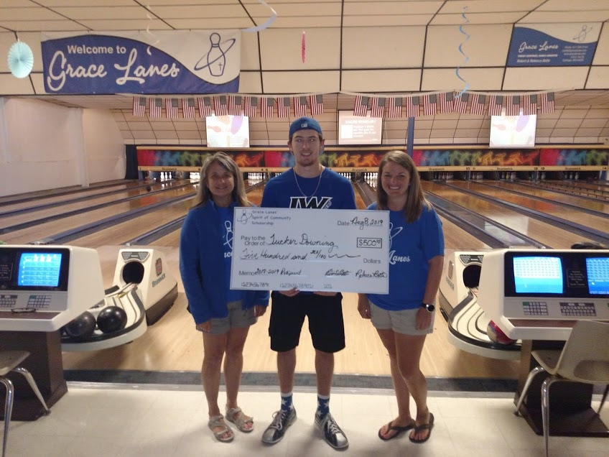 The 2018-2019 recipient of the Spirit of Community Scholarship is Tucker Downing. He will be attending Iowa Western Community College in Council Bluffs Iowa in the Fall of 2019.
Your AD Here

Grace Lanes
Spirit of Community Scholarship
Contact Rebecca at r.botts@gracelanes.com for billing and instructions for sending vector/jpeg image for tile. Payment and image due by October 1, 2019. Ad placement preference given on first come, first served basis.
Thank you!

